Confidential Client In-Take Form – Therapeutic Massage
First Name: Last Name: | Date:
Address: | Occupation:
City: State: Zip Code: | Date of Birth:
Email: | Phone:
Emergency Contact Name& Phone: | Name of Referral:
Do you want to be on our list for promotions?  Yes____ No ____ | How did you hear about us?
Please take a moment to carefully read/fill-out the following form and sign where indicated. If you have a specific medical condition or specific symptoms, massage/bodywork may be contraindicated. A referral from your primary care provider may be required prior to service being provided.

1. Have you had a professional massage before? Yes________ No _________
If yes, how often do you receive massage therapy? __________________________________
What type of massage are you seeking? Relaxation_________ Therapeutic/Deep Tissue __________

2. Preferred pressure of your massage: light _______ medium ________ firm __________
3. Do you have any difficulty lying on your front, back, or side? Yes_________ No___________
If yes, please explain___________________________________________________________
4. Do you frequently suffer from stress? Yes ______ No______ Stress Level: ______________________
5. Have you had any surgery? Yes ____ No_____ If yes, please explain________________________
6. Do you have any allergies to oils, lotions, or ointments? Yes _______ No________
If yes, please explain___________________________________________________________
7. Is there a particular area of the body where you are experiencing tension, pain or other discomfort?
Yes _______ No________ If yes, please identify_________________________________________
8. Are you currently under medical supervision? Yes _____ No______
If yes, please explain__________________________________________________________________
9. Have you had any orthopedic injuries? Yes ______ No_______

If yes, please list: _________________________________________________________________

10. Is there anything on your health history that would be useful for your massage therapist in order to plan a safe and effective massage session for you?
Yes ____ No_____ If yes, please explain_________________________________________________
10. Are you pregnant? (Female only) Yes ____ No ____How many weeks? _____________________
11. Draping will be used during the session – only the area being worked on will be uncovered.
12. Please indicate or circle on the diagrams any areas of concern or areas requiring special attention, and explain below.
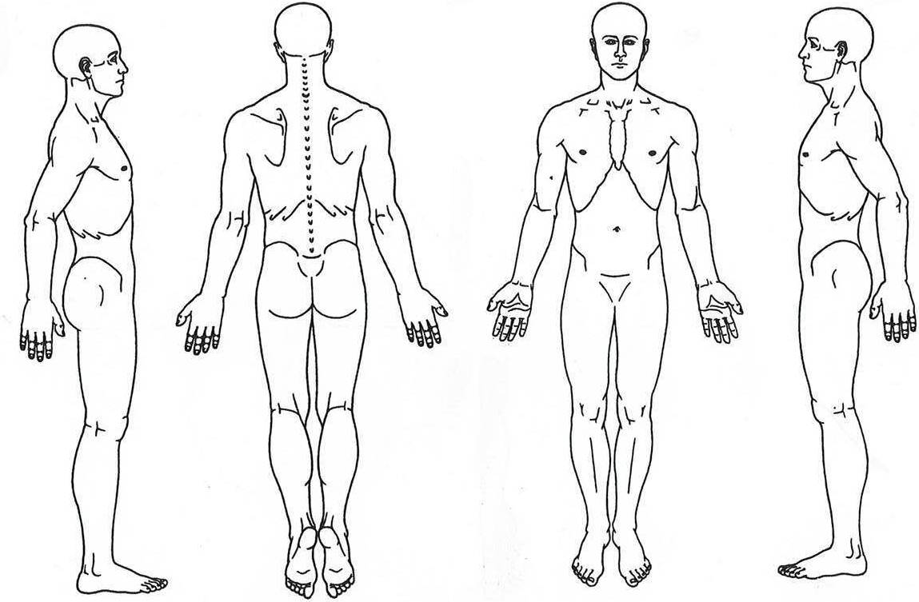

Comments:

__________________________________________________________________________________________________
All Clients
CANCELLATION POLICY
Your spa treatments are reserved especially for you. We value your business and ask that if you are unable to make your appointment, to please give us 24 HOUR NOTICE and we will be happy to reschedule your appointment to a more convenient time. We recognize that the time of our clients and staff is valuable and this is will allow other clients to use the now available time slot. Clients who miss their appointment without giving any prior notification will be considered a “NO SHOW” and will be charged in full for the scheduled service. Clients who cancel with LESS THAN 24 HOUR notice will be charged half of the scheduled service rate. We do understand that emergency situations happen and will do our best to accommodate your situation.
LATE ARRIVALS
while we do our best to accommodate all clients, and understand that being late is sometimes unavoidable, we ask that if you are running late to please call and let us know. We prefer not to have to shorten or reschedule appointments but depending on circumstances and availability may need to and you will still be responsible for payment for the full service.
If you are more than 15 minutes late and do not let us know, your appointment may be cancelled and will be considered a “NO SHOW” in which the cancellation fee will apply.

PRODUCT & GIFT CERTIFICATE POLICY
*Any unopened & unused products can be returned or exchanged within 14 days with original receipt. We are unable to process any returns or reimburse any payment transactions on gift certificates, even if lost, misplaced or stolen. Gift certificates cannot be redeemed for cash and cannot be applied to gratuities. *All Spa Series, Gift Certificate and Spa Membership sales are final and non-refundable.

I, _________________________________ (print name) understand, have read and completed this questionnaire truthfully and that the massage I receive is provided for the basic purpose of relaxation and relief of muscular tension. If I experience any pain or discomfort during this session, I will immediately inform the therapist so that the pressure and/or strokes may be adjusted to my level of comfort. I affirm that I have stated all my known medical conditions, and answered all questions honestly. I am aware that it is my responsibility to inform the Annie Beauty Spa professional of my current medical or health conditions and to update this history. The treatments I receive here are voluntary and I release Annie Beauty Spa and/or the Therapist/professional from liability and assume full responsibility thereof.

Client Signature______________________________________ Date _________________________

